**Ideation Phase**

**Define the Problem Statements**

|  |  |
| --- | --- |
| Date | 29 June 2025 |
| Team ID | LTVIP2025TMID54764 |
| Project Name | HouseHunt: Finding Your Perfect Rental Home |
| Maximum Marks |  |

**Customer Problem Statement Template:**

To define the core problems freelancers face while searching for jobs online, and use those insights to guide the development of Freelance Finder.

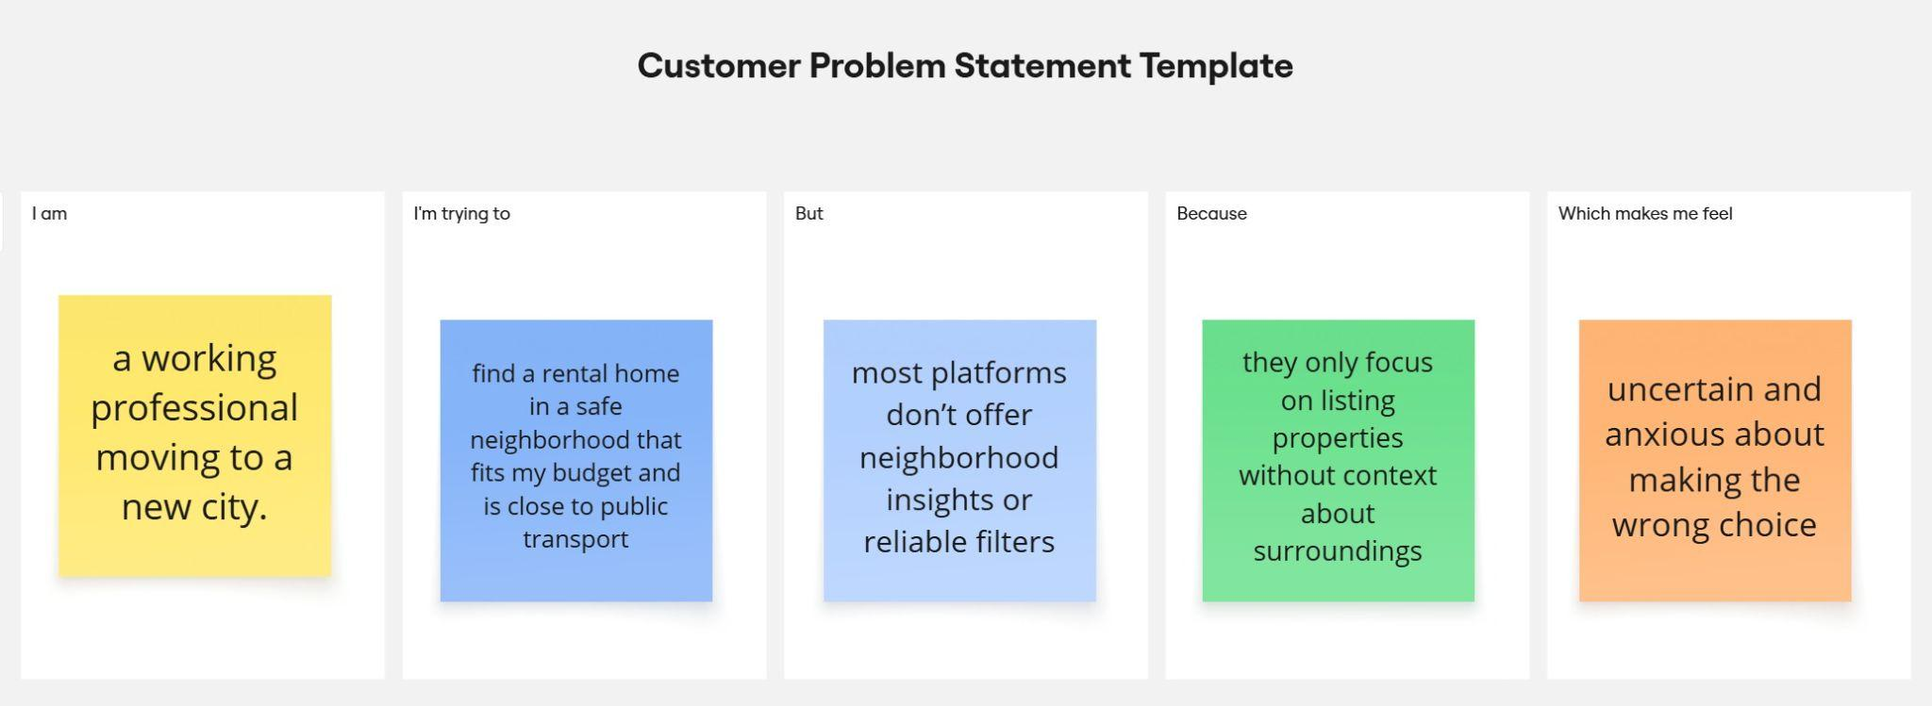

Reference: <https://miro.com/templates/customer-problem-statement/>

|  |  |  |  |  |  |
| --- | --- | --- | --- | --- | --- |
| **Problem Statement (PS)** | **I am (Customer)** | **I’m trying to** | **But** | **Because** | **Which makes me feel** |
| PS-1 | a working professional moving to a new city. | find a rental home in a safe neighborhood that fits my budget and is close to public transport | most platforms don’t offer neighborhood insights or reliable filters | they only focus on listing properties without context about surroundings | uncertain and anxious about making the wrong choice |
| PS-2 | a student looking for an affordable rental near campus | find a verified listing with roommates or shared housing | there’s no clear way to identify legit shared housing options | many listings are outdated or unverified | confused and frustrated during my search |